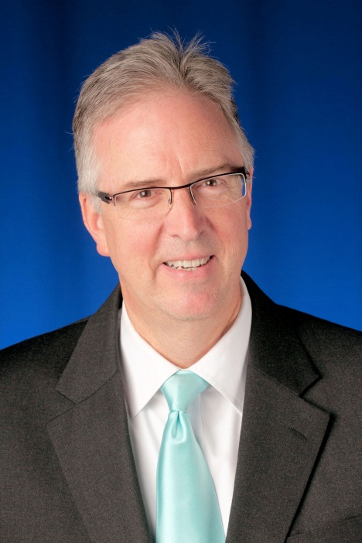David H. Layer

David Layer is Senior Director, Advanced Engineering in NAB’s Technology Department. David has been with NAB since 1995, and has been very active in the radio technology and standards setting area. He is the primary NAB staff person on NAB’s Radio Technology Committee and the National Radio Systems Committee (NRSC), a technical standards setting body co-sponsored by NAB and the Consumer Electronics Association (CEA).

David’s duties within NAB are varied and broad. His current principal responsibilities include serving as a project manager for technology projects being conducted by NAB Labs, and as principal administrator of the NAB Labs Radio Technology Committee, a group of technical executives from NAB member companies that advises NAB on technology development and technical regulatory matters. Additionally, David provides technical expertise to NAB’s Government Relations and Legal departments on regulatory and legislative matters which pertain to the broadcasting industry.

David is actively involved in NAB's technical conference planning and technical publication activities, and has been an author and contributing author for numerous technical publications, including IEEE Spectrum magazine (a leading journal of the Electrical Engineering profession), the McGraw-Hill Yearbook of Science and Technology, and both the 9th and 10th editions of the NAB Engineering Handbook. David is an occasional author of NAB’s Radio and TV TechCheck newsletters which are NAB member publications covering timely radio and TV broadcasting-related technical topics.

Outside of NAB, David is a Senior member of the IEEE and is active in the IEEE Broadcast Technology Society, where he serves on the Administrative Committee, is a Distinguished Lecturer, and has been the chair or co-chair of six annual IEEE Broadcast Symposia (most recently in 2013). David is an associate member of the Association of Federal Communications Consulting Engineers (AFCCE) where he is currently a board member and is past chair of the AFCCE Scholarship Committee. David was recognized by Radio Ink Magazine in November 2010 as among the top ten Best Engineers in Radio, and in 2014 received the Consumer Electronics Association Technology Leadership Award.